1. (1)
- focus of expansion (FOE): if 3D point field moving toward camera
- FOE: motion-field vectors radiate outward from that point
(2)
- focus of contraction (FOC): if 3D point field moving away from camera
- FOC: vectors radiate inward toward diametrically opposite point flow pattern of the motion field of a forward-moving observer
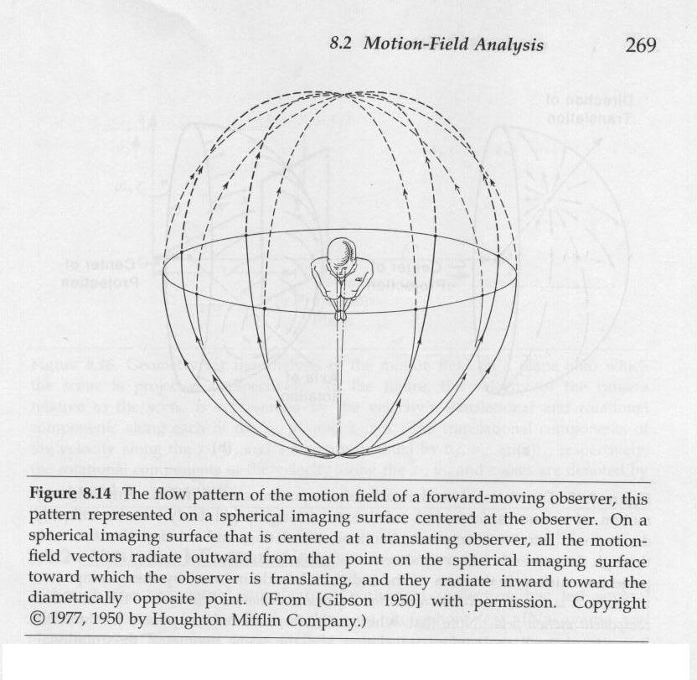
(3) intersection lines of epipolar plane and image planes
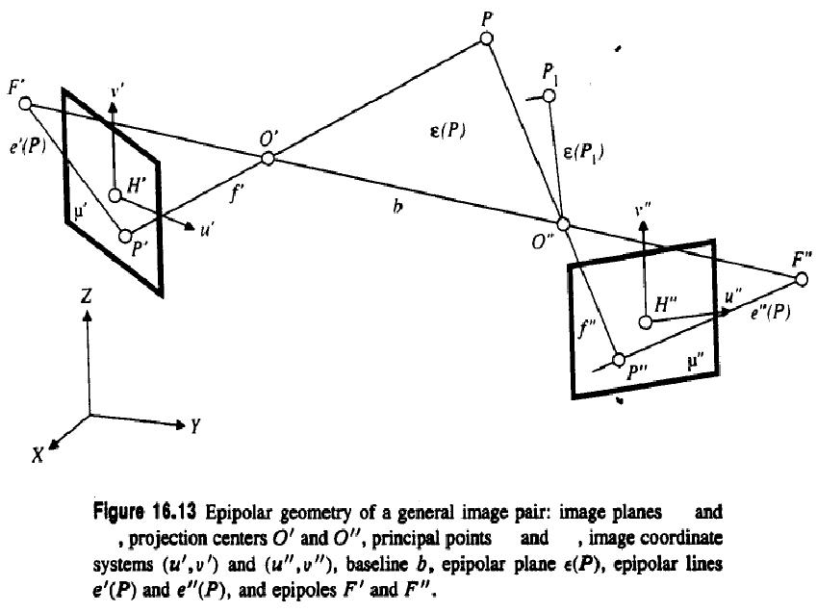

(4)
- position on digital grid: has inherent quantizing error due to discreteness
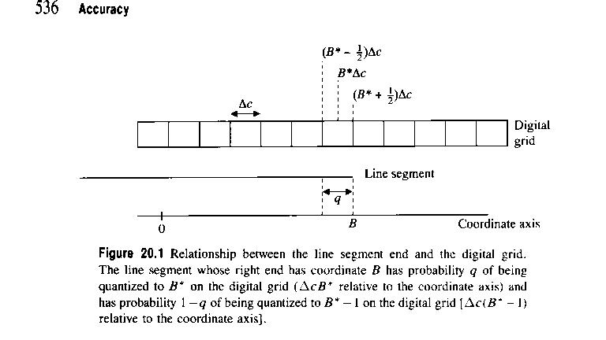
2.
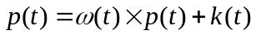*rigid body motion equation:
ω(t): angular velocities in three axes
k(t): translational velocities in three axes
*Rigid-body motion: no relative motion of points w.r.t. (with respect to) one another
points maintain fixed position relative to one another
all points move with the body as a whole
*a rigid body is an idealization of a solid body of finite size in which deformation is neglected.

3.
To infer depth information: translation needed in perspective projection
To infer depth information: rotation useless in perspective projection
To infer depth information: rotation needed in orthographic projection
To infer depth information translation useless in orthographic projection
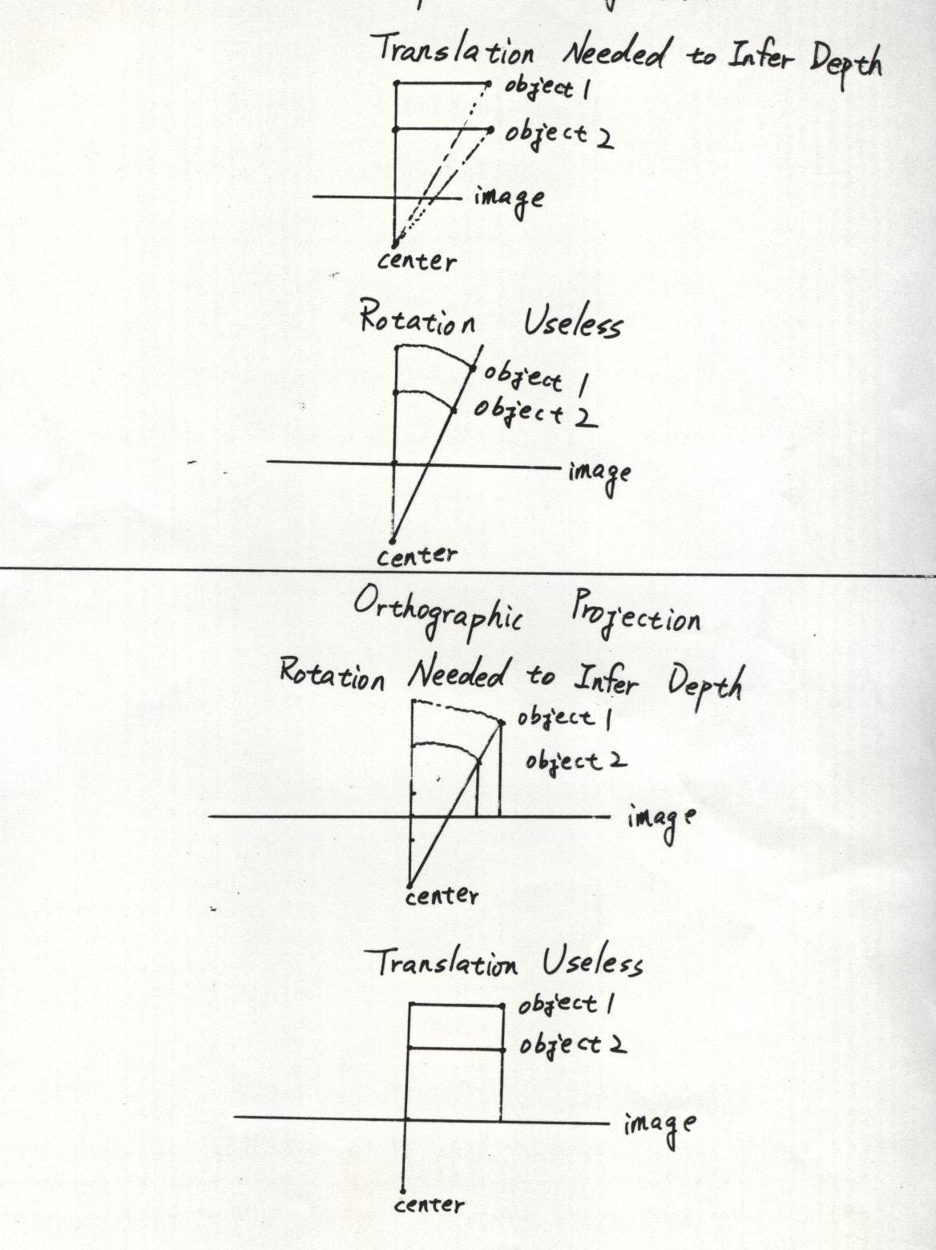

4.
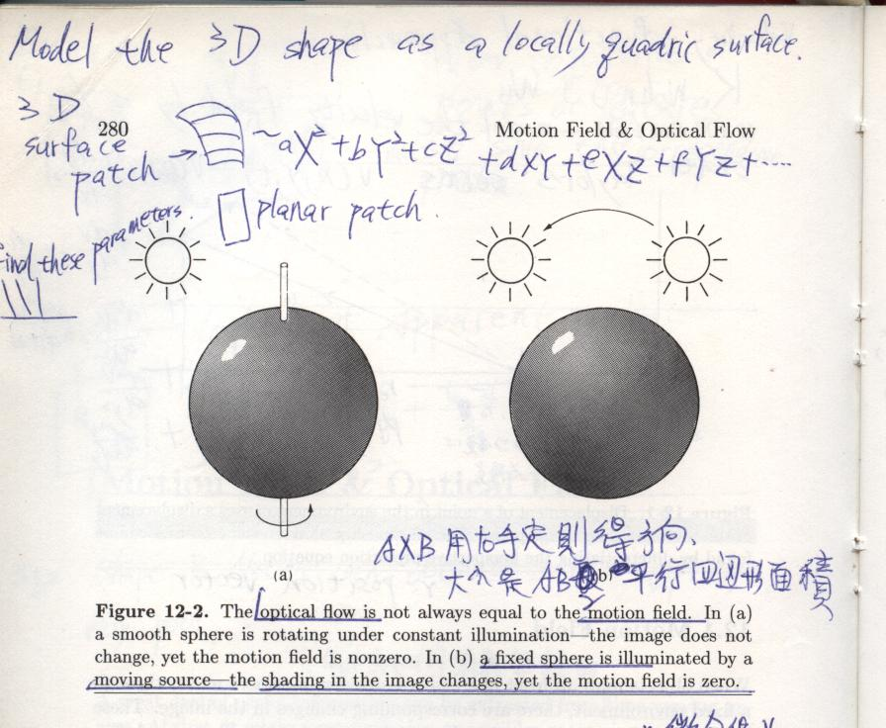
5.

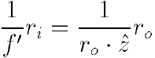
- ri: distance between perspectivity center and image point
- ro: distance between perspectivity center and object point
- f’: camera constant
- z: depth axis, optic axis

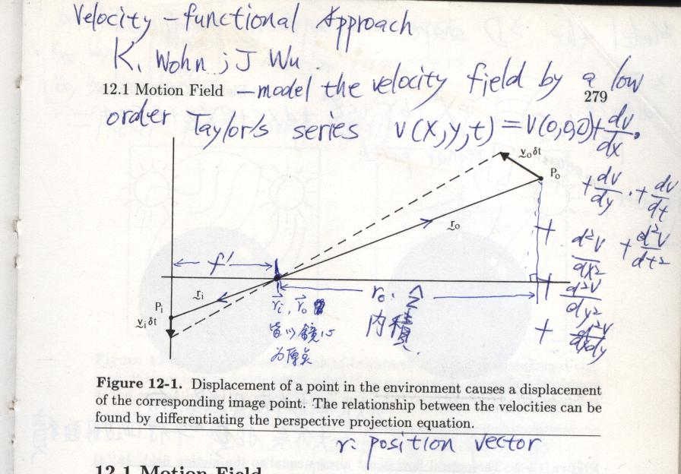
6.
  - time-varying sequences for recognizing parts in motion
- visual inspection of geometry of 3D parts
- medical diagnosis of beating hearts
- monitoring land use
- deriving topographic maps from satellite or aerial imagery
- analysis of slices of computer tomography images
7.
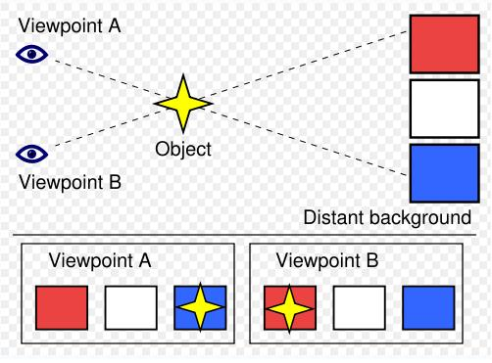
When viewed from Viewpoint A, the object appears to be closer to the blue square. When the viewpoint is changed to Viewpoint B, the object appears to have moved in front of the red square.
8.
monotonic-ordering assumption: conjugate image points have same order
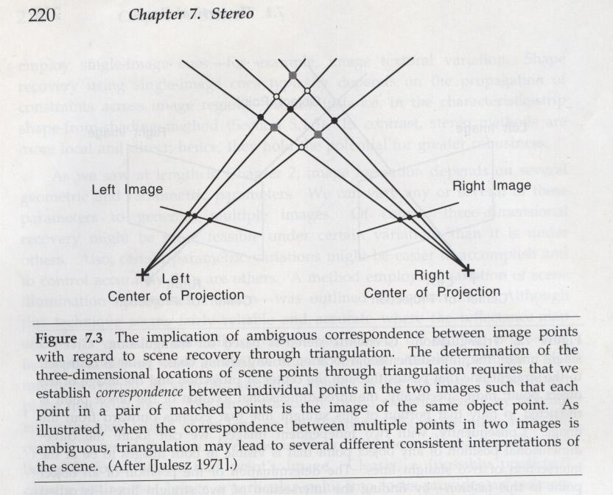
black points satisfied with monotonic-ordering assumption
9.
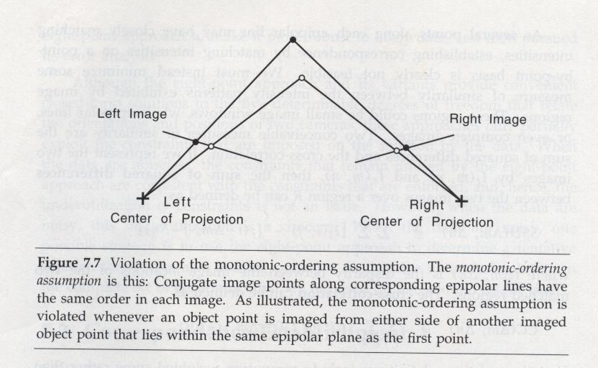
10.
1. distinctness: distinguishable from immediate neighbors
distinct points: corners, blobs, highly textured places, etc.
2. invariance: position and selection invariant w.r.t. geometric distortion
invariance and distinctness: influence all subsequent steps in analysis
3. stability: position and selection invariant w.r.t. viewing
stability: ensures interesting points in image correspond to object points
corner points of polyhedra: stable
T-junction: unstable since it results from occlusions
stability: decisive for image-matching 3D reconstruction
4. uniqueness: global separability, i.e. imagewide separability
distinctness: aims at local separability
uniqueness: to avoid locally distinct but repetitive features or points
uniqueness: closest notion to interestingness
5. interpretability: requires extracted points to have meaning
e.g. corners, junctions of lines, centers of circles, rings, etc.

11.

CLP = ( U, L, T, R)

U: the objects to be labeled
L: the set of possible labels
T: the unit-constraint relation
R: the unit-label constraint relation

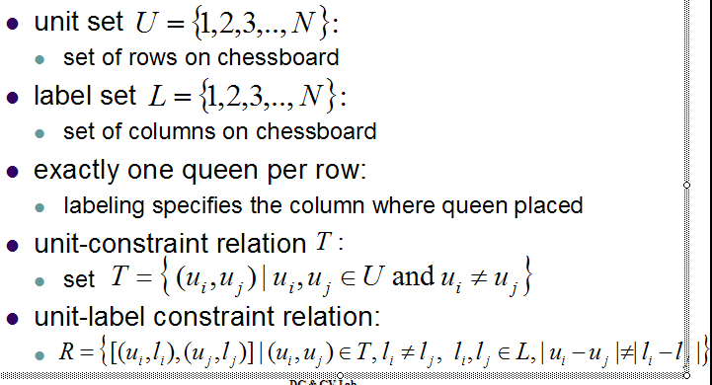
12.
U = {1,2,3,…, N}
L = {1,2,3,…, N}
T = {(u_{i},u_{j}) | u_{i},u_{j}U and u_{i}u_{j} }
R = {[(u_{i},l_{i}),(u_{j},l_{j})] | (u_{i},u_{j})T, l_{i}l_{j}, l_{i},l_{j}L, |u_{i}-u_{j}||l_{i} - l_{j}|}

13.
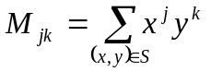a.

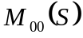b.
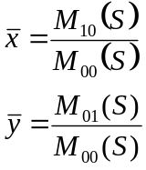c.

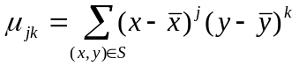d.
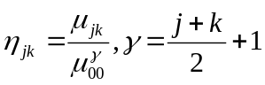
e.

14.
a. viewpoint in perspective projection: center of projection
viewpoint in orthographic projection: direction of projection
b. complete loss of depth information
c. Add line labels for visible projections of surface-normal discontinuities like following:
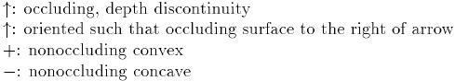

15.

Bottom-up hierarchical control
Top-down hierarchical control
Hybrid control with feedback
Knowledges sources arranged in a hierarchy heterarchical control
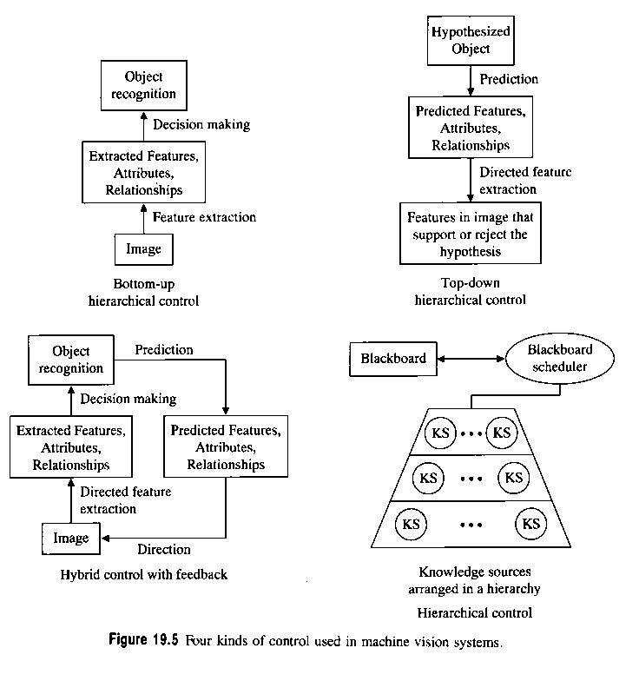

16.
  - quantity (or quantities) to be measured
  - accuracy of measurement
  - population of scenes/images or artificially generated data

